1.Opening the Steps Recorder
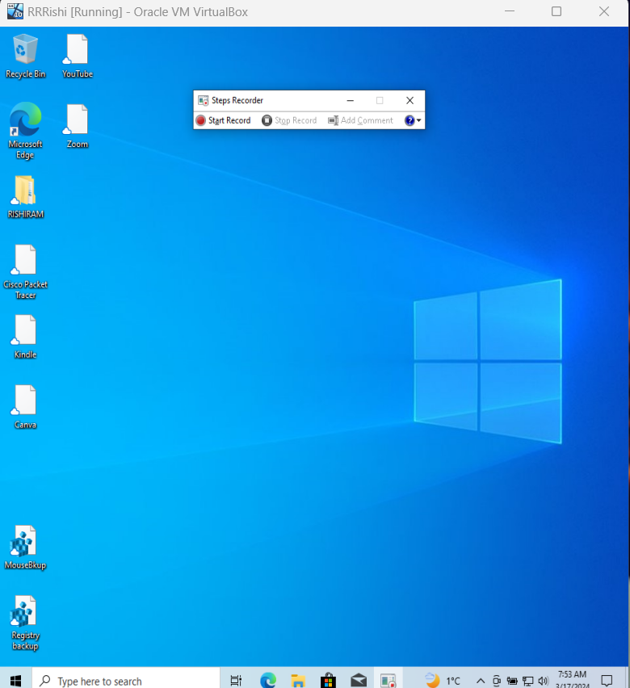
Click on Start Record
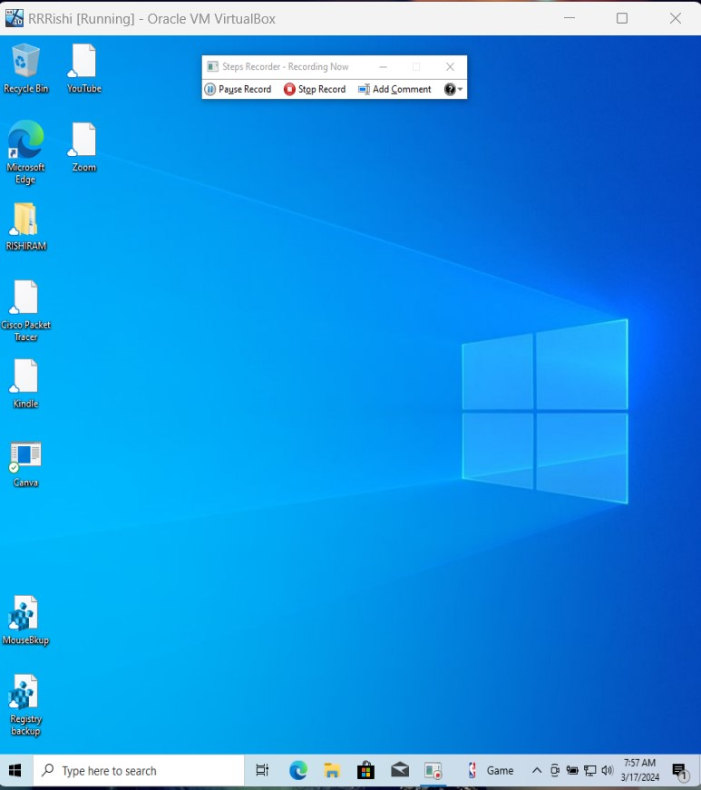

Click on the browser
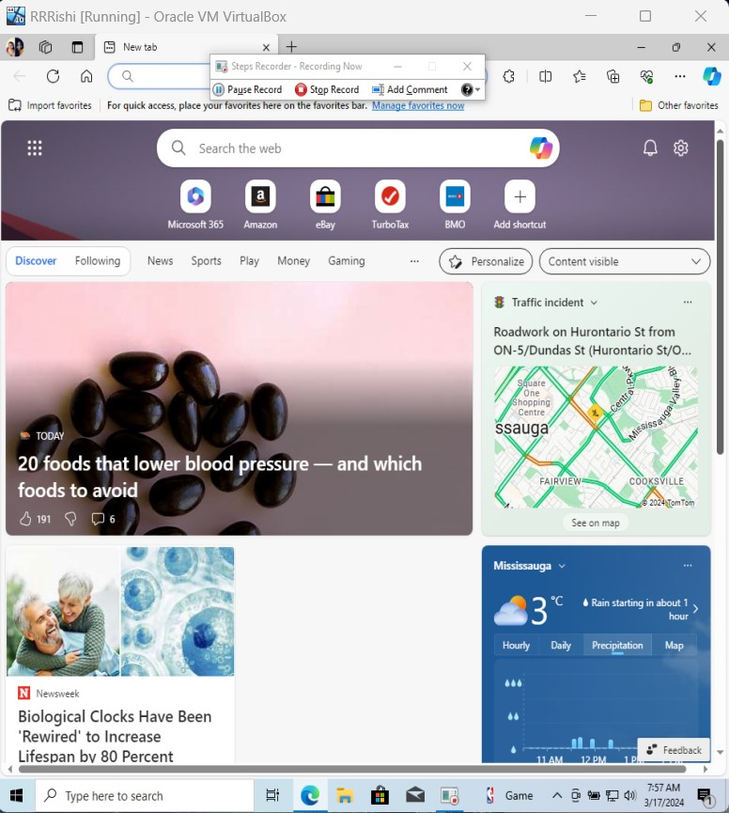
Unable to open an app in the VB
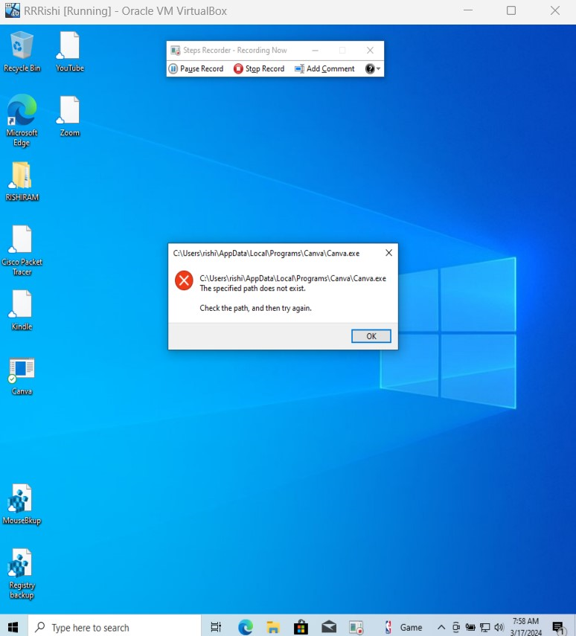

Click on Pause Record, we can see the steps did on system were recorded
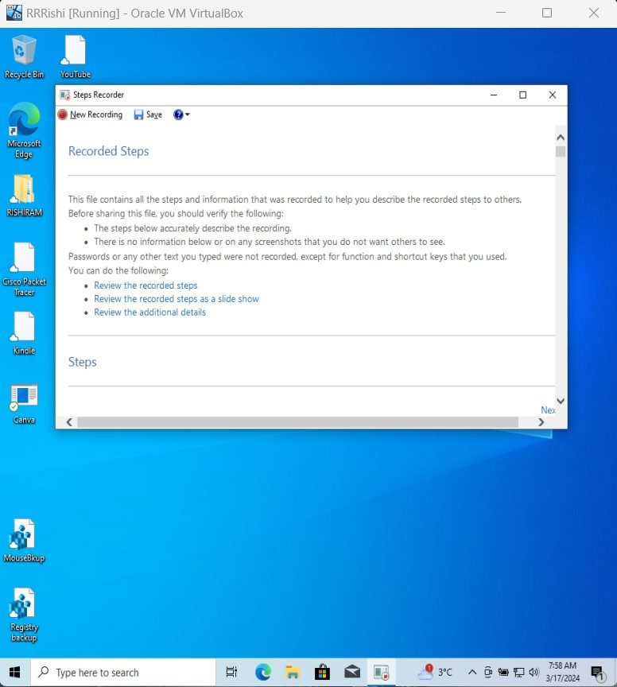
Click on steps in we can see all the steps I did which has been recorded
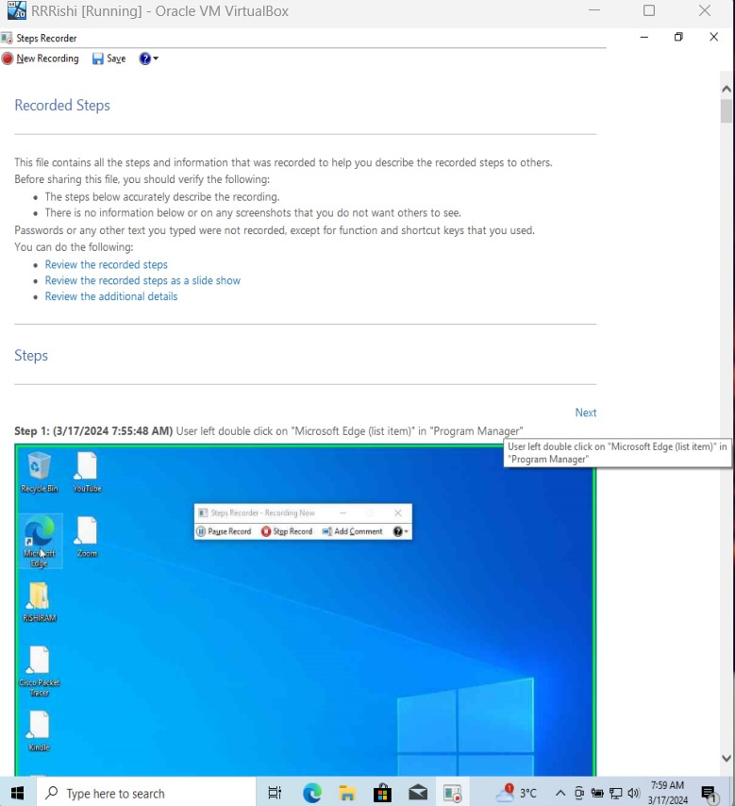

Scroll down and we can see the Additional details to know the timing of the steps I did while steps recorded was switched on
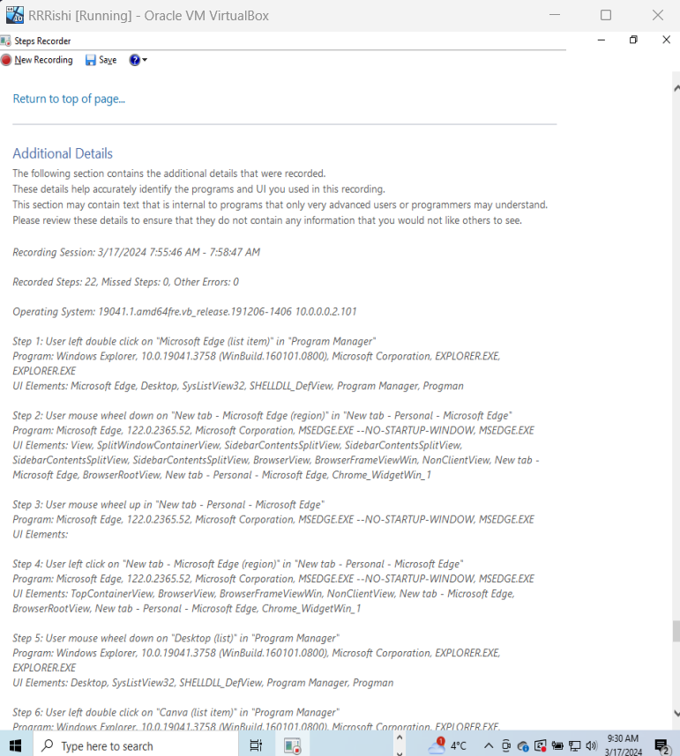
Click on Save to save the steps that has been recorded.
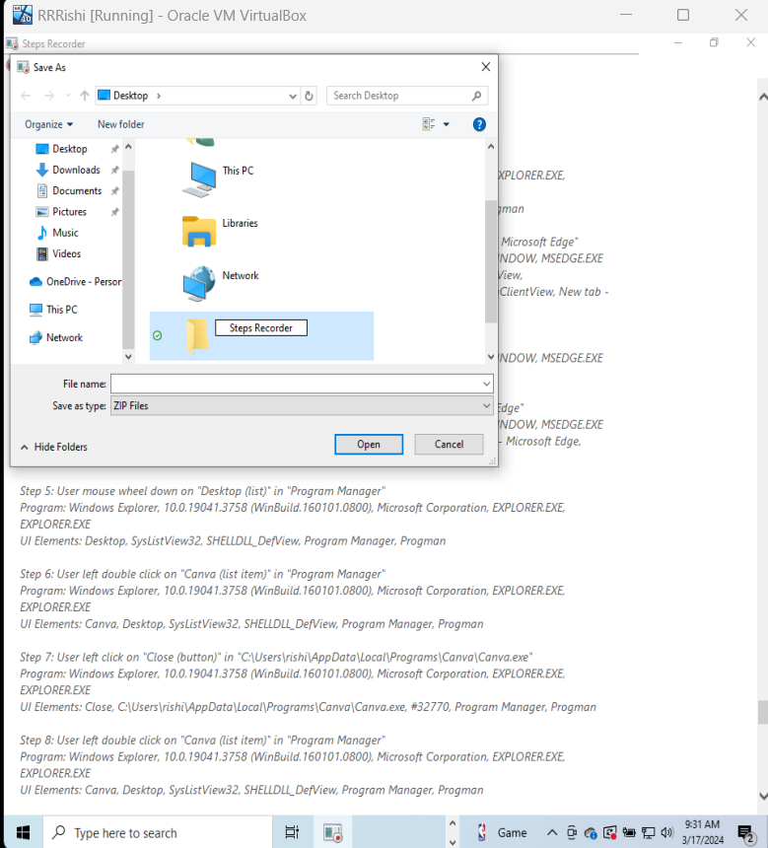
Click on Open now we can see that “Steps Recorder Folder has been created and the file is saved”.ssssssssss
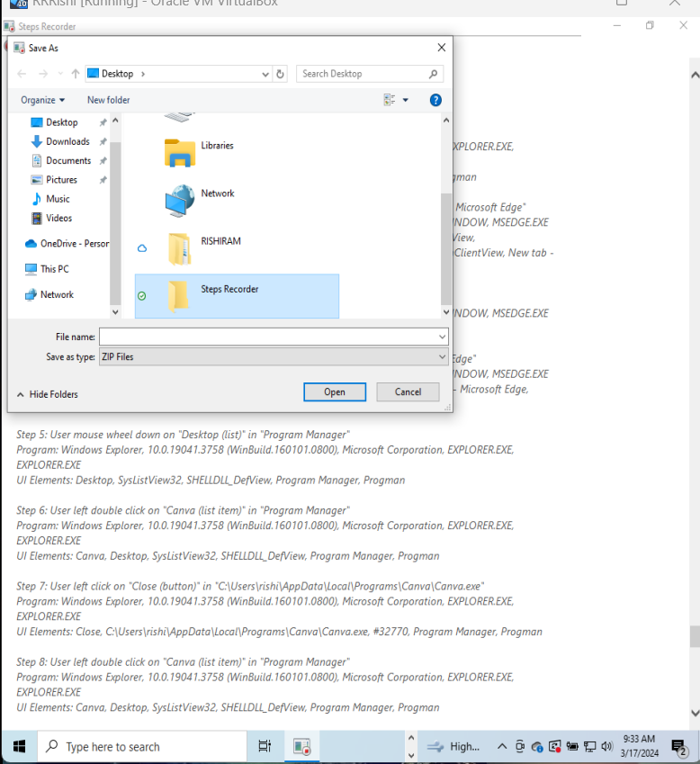
2.Quick Assist – Find quick assist on start menu on VB_1 that is technician account
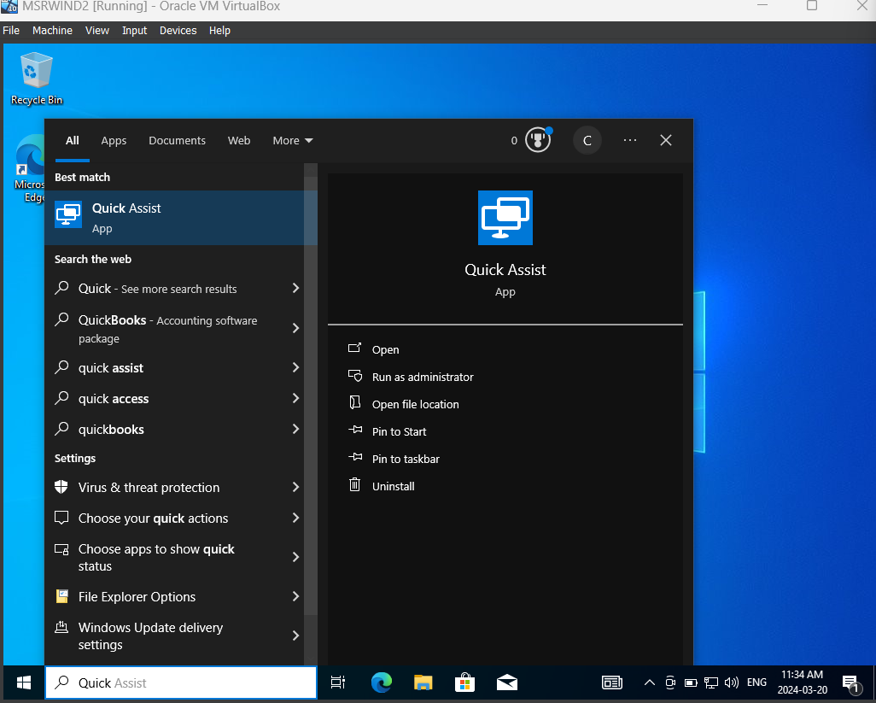

Click on the quick assist
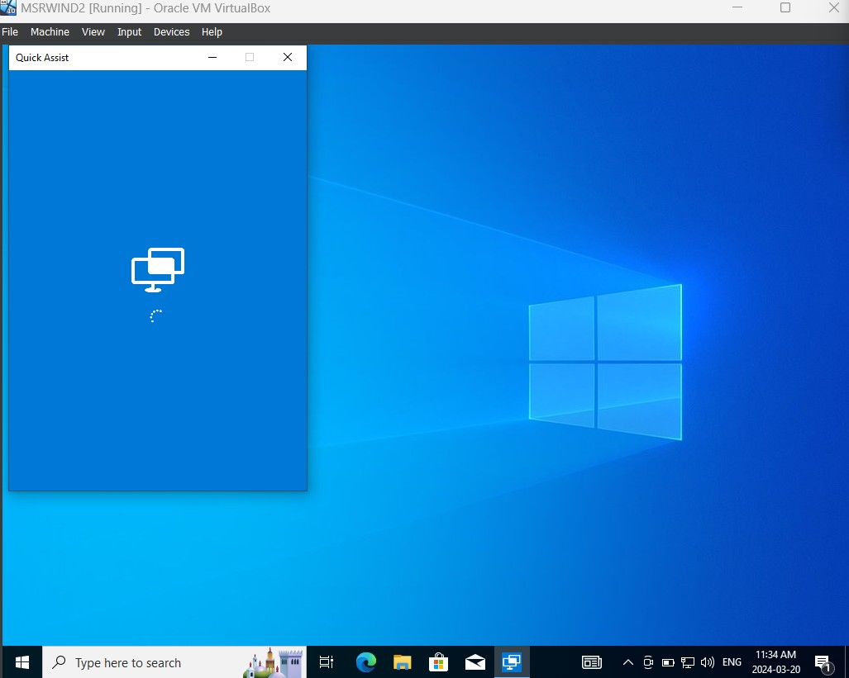
Click on help someone (as it is technician account)
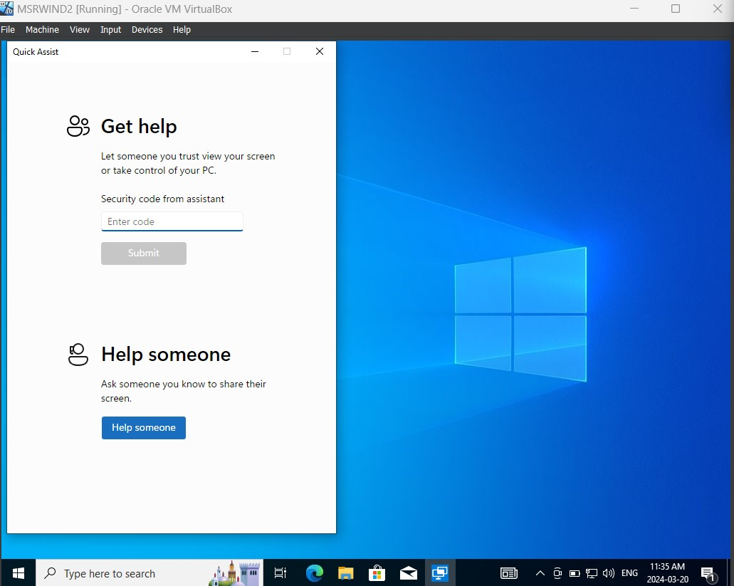

Enter the Hotmail credentials of the technician account
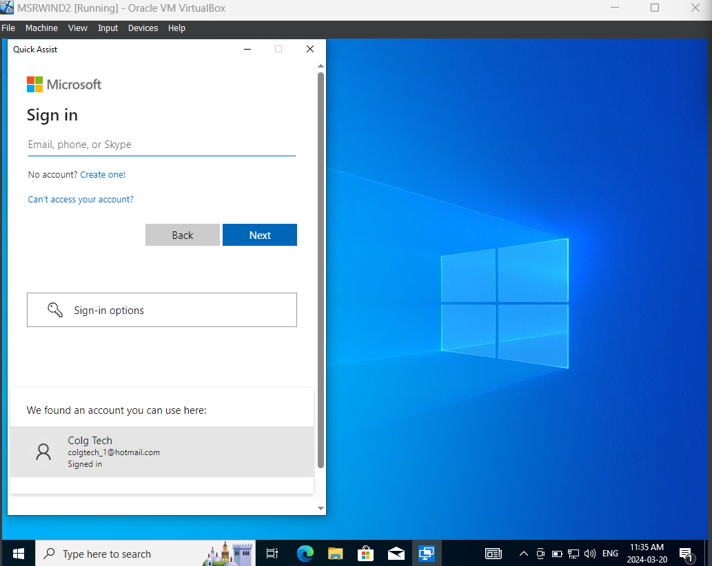
Copy the code
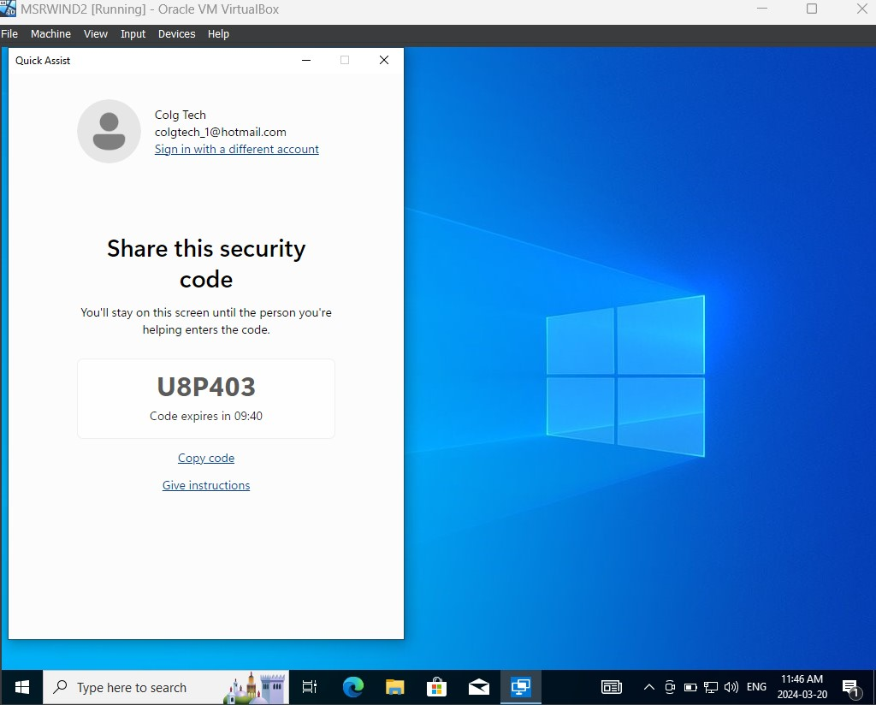
Login to VB_2 which is the user account, find Quick Assist on the start menu then click on Quick Assist
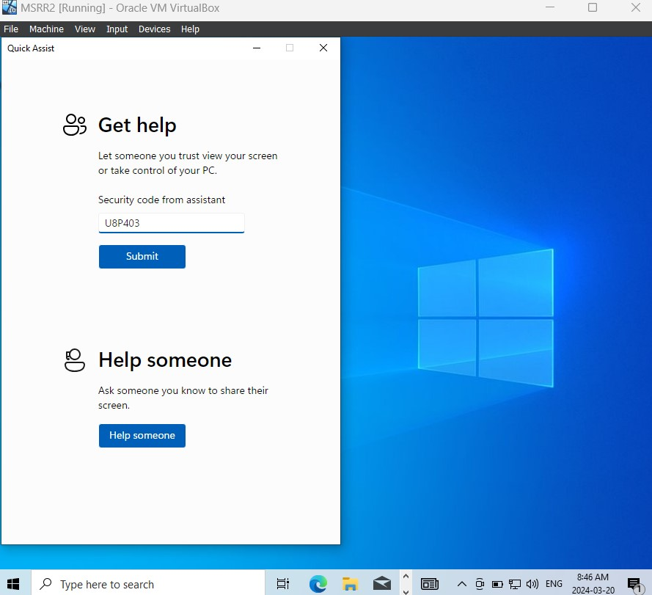
Click on Help Someone and paste the code in user account that is copied from technician account
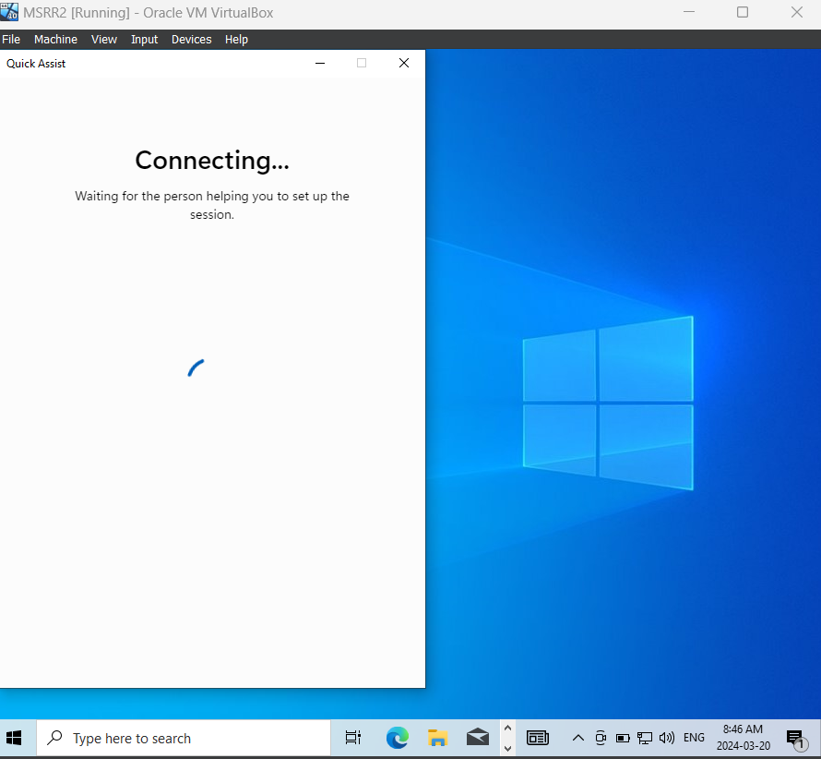
Click on Allow for Screen Sharing
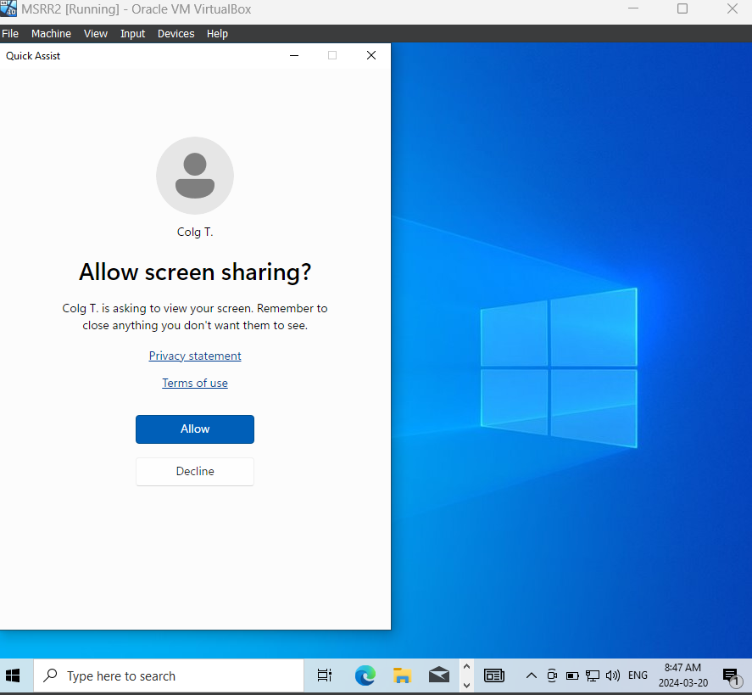
Now, the Technician account can be able to see the User account screen
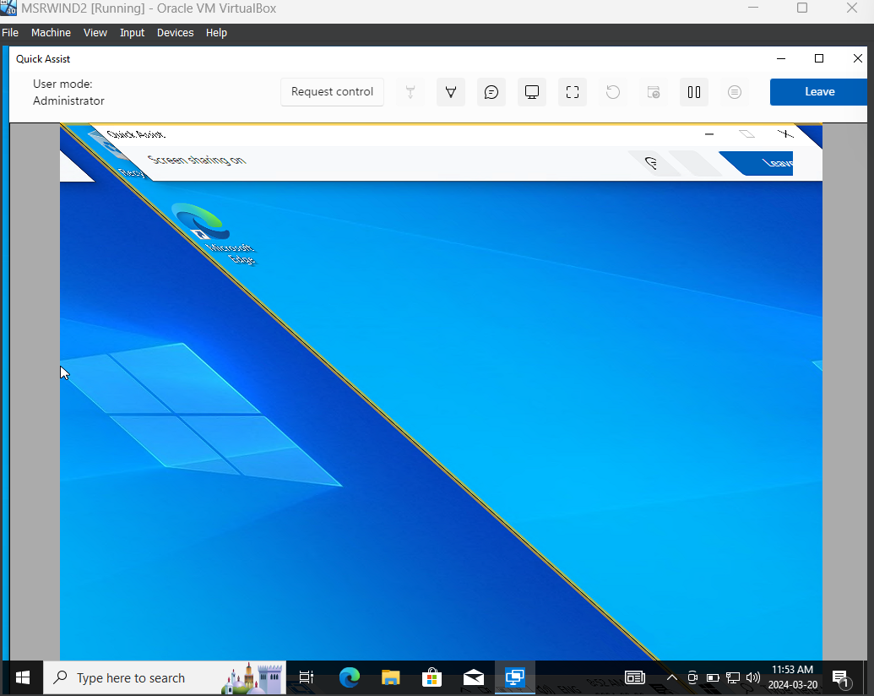
Click on Annotate
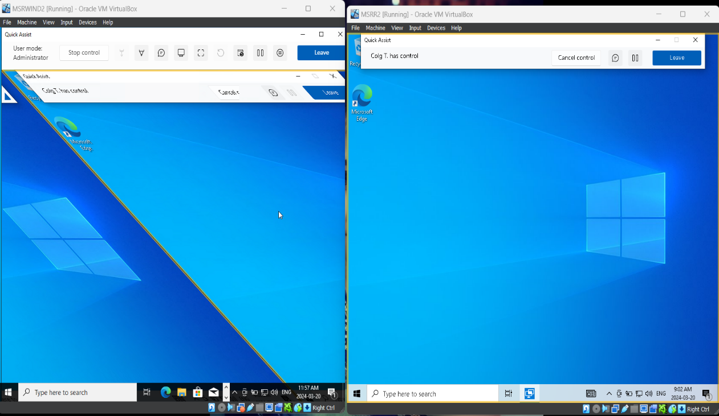
The technician is able to annotate on Users Screen
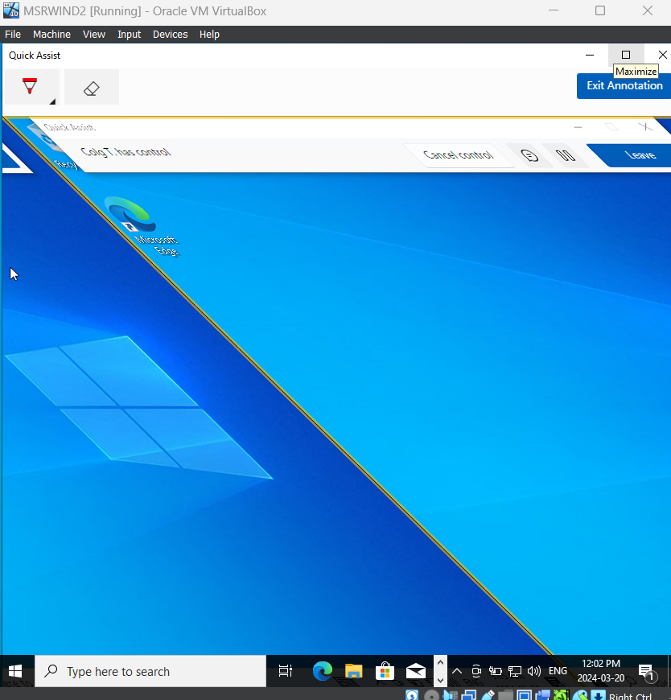

Click on Administrator in Technician account’s user screen
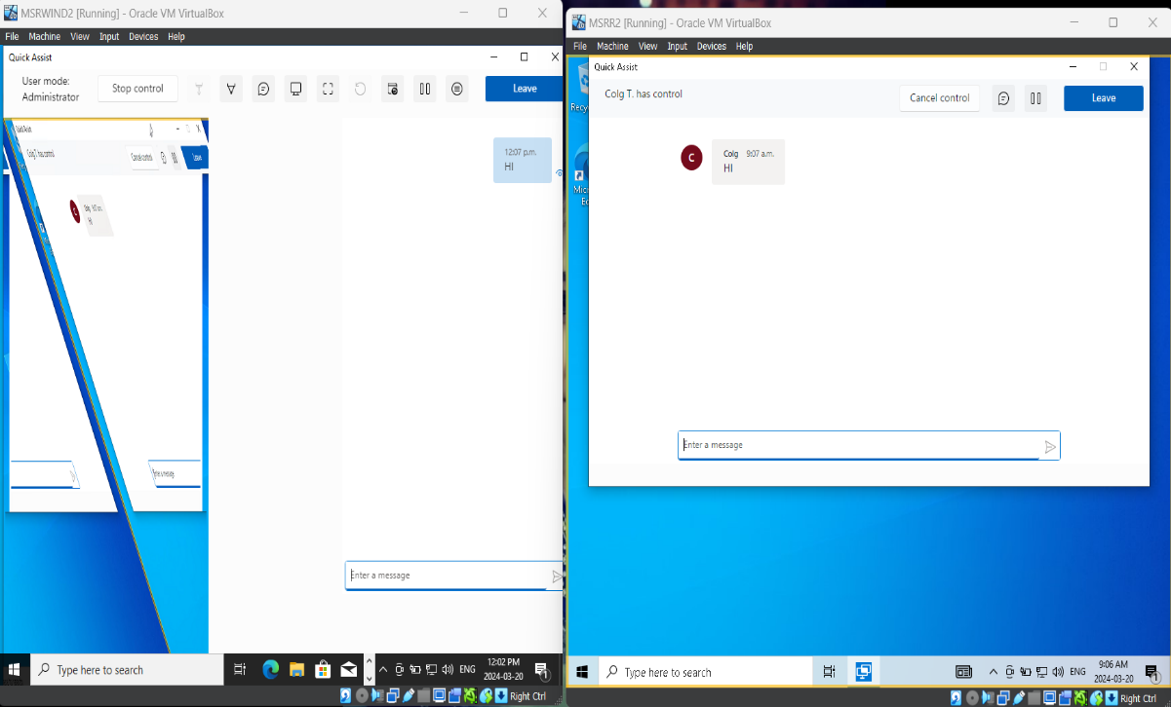
Message to the user and the User can see the message from the Technician.
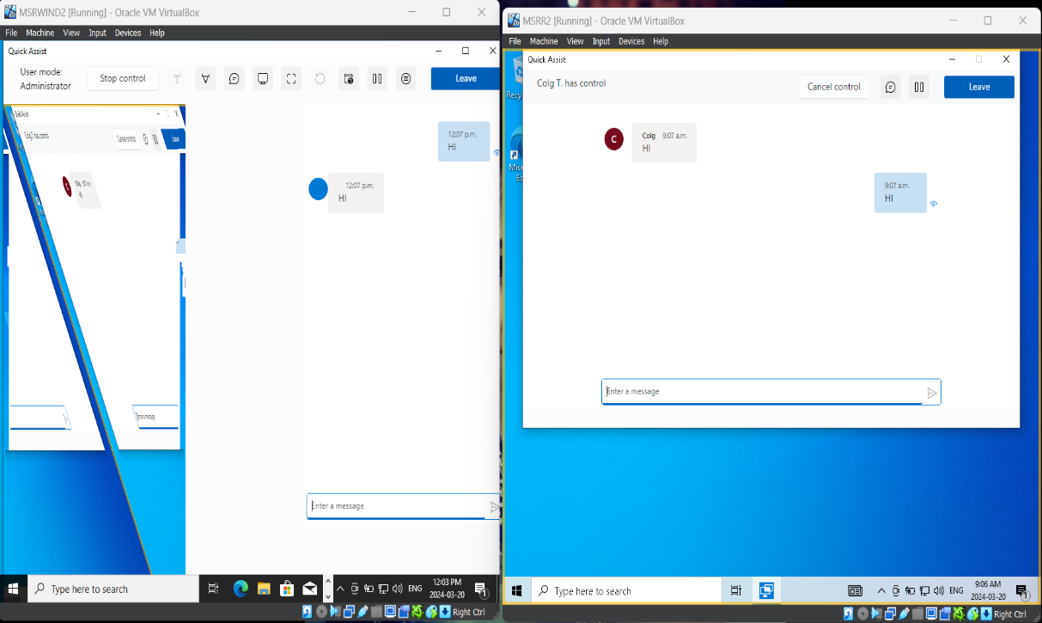

Click on Fit Screen
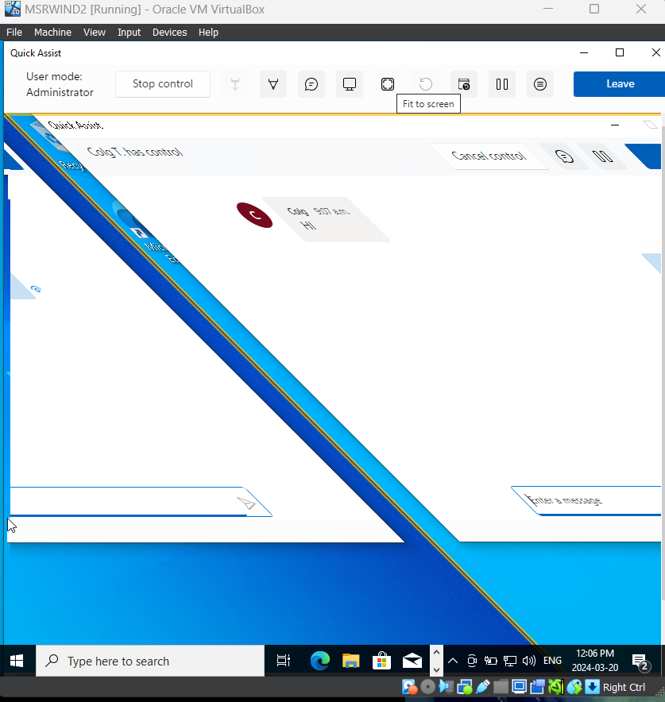
Click on Actual Size
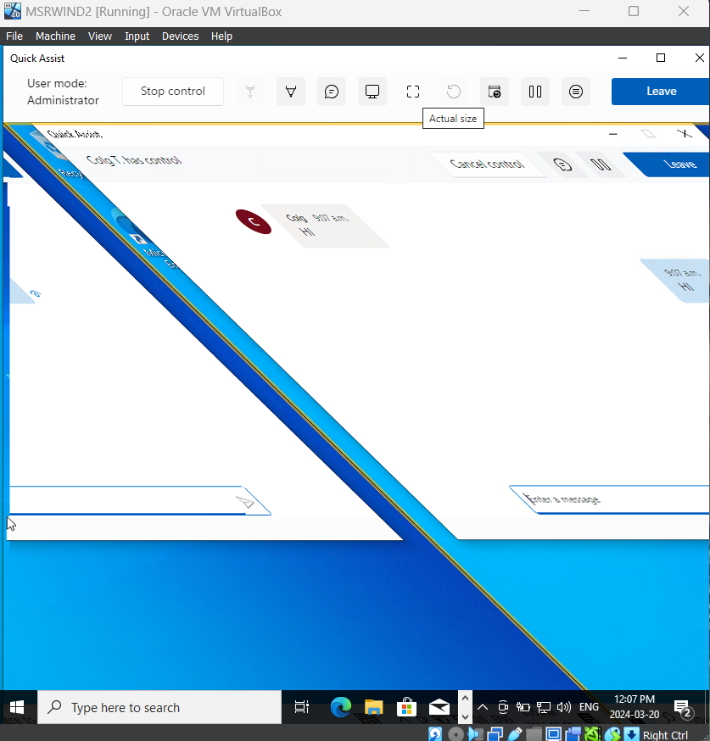
Click on Task Manager of the User screen.
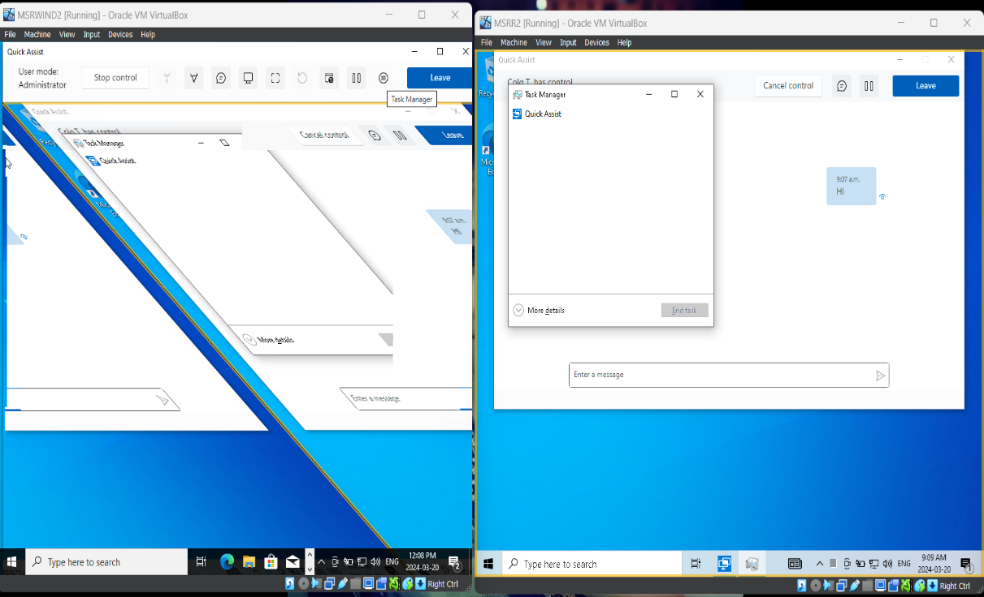
Now we can help a user from a technician’s device using quick assist.
3.Enabling Remote Desktop Connection in the Host machine which is in Windows 11.
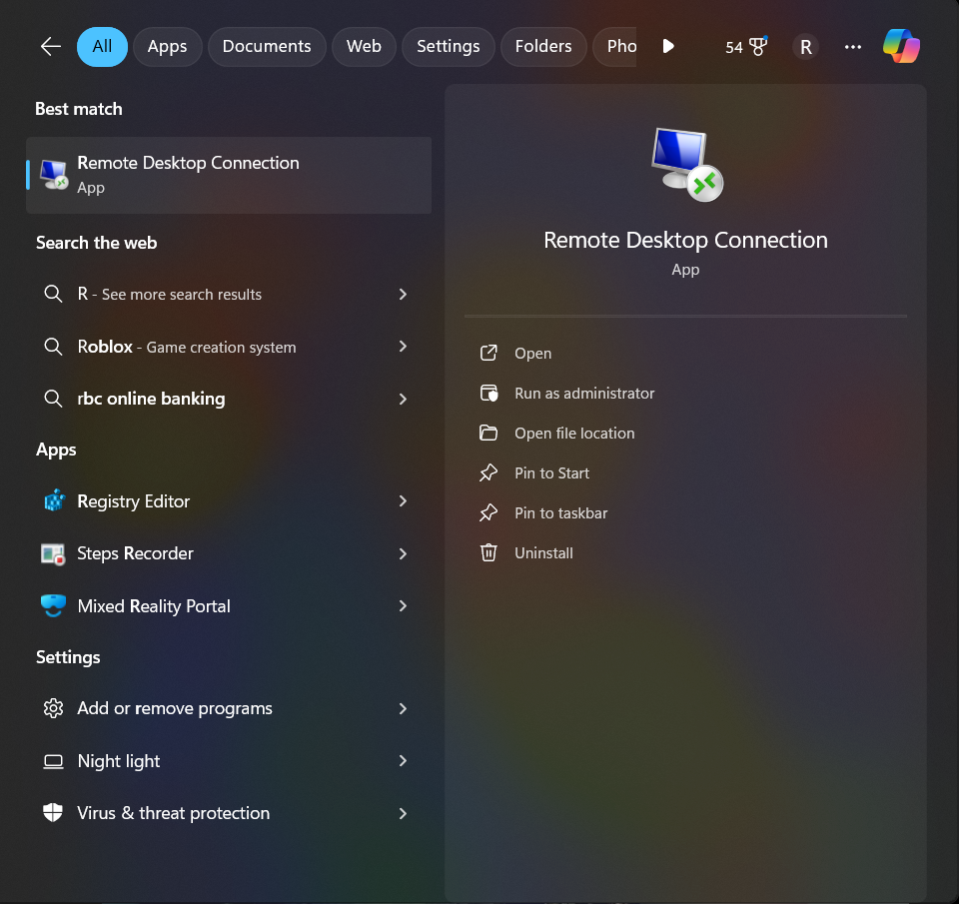

Find the remote desktop connection in start menu.
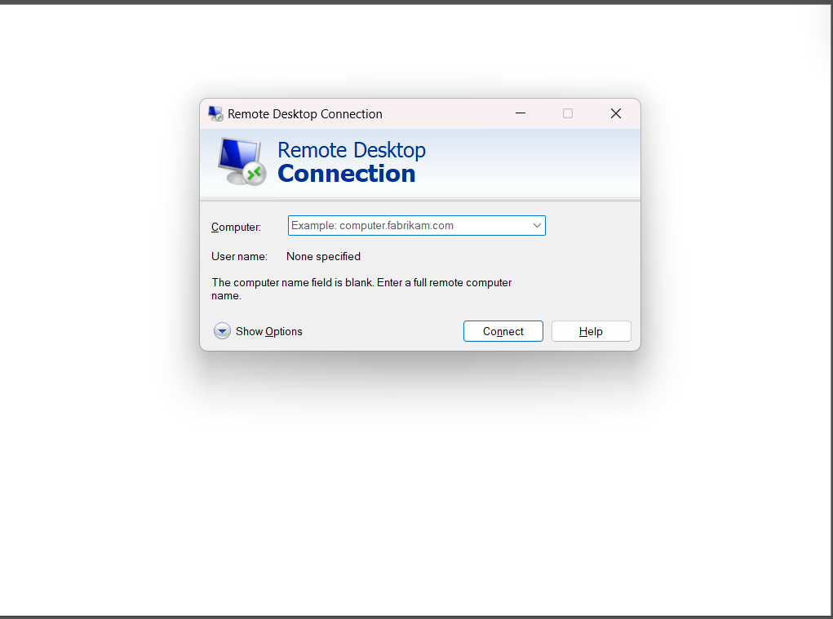
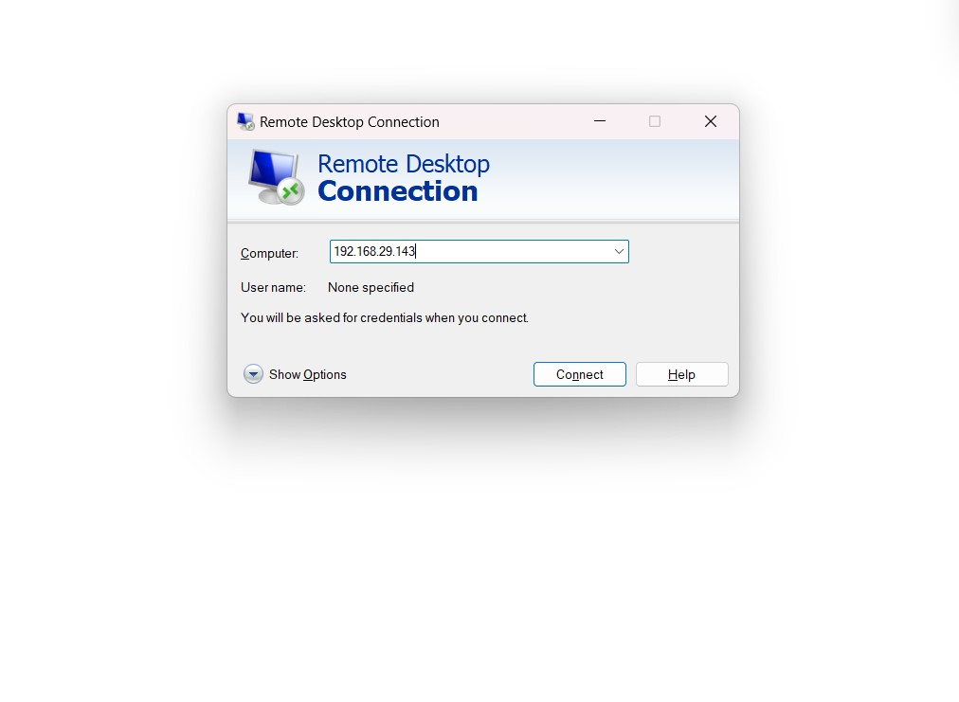
Enter the ip address of the device we need to remotely access.

Click on Connect
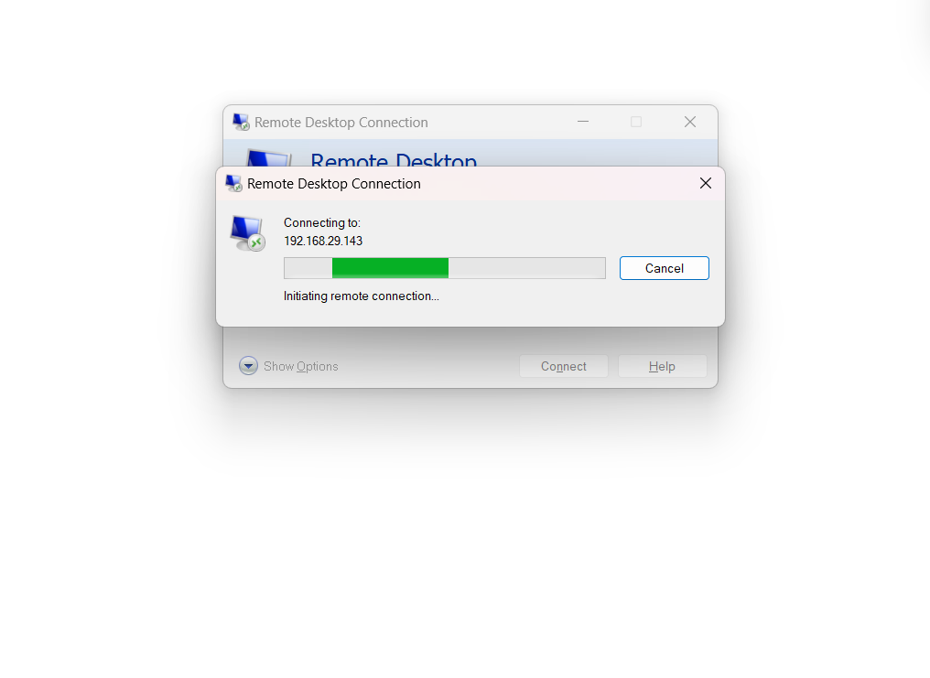
We will not be able to connect and will get a error message as remote desktop is not enabled in the host machine.
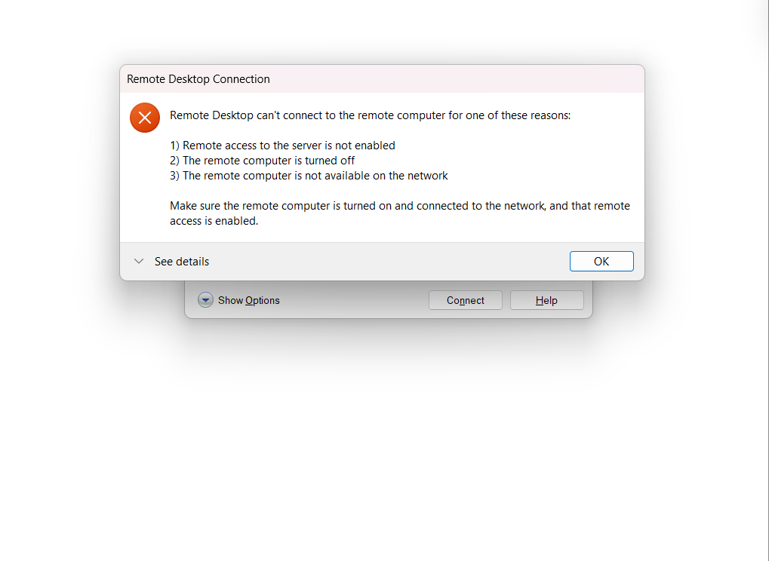

Click on settings
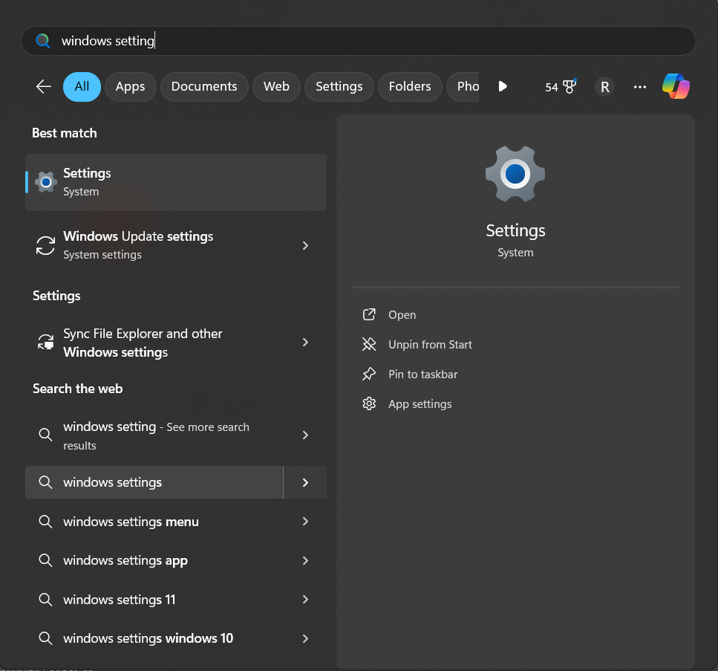
Click on System, scroll down and click n remote desktop
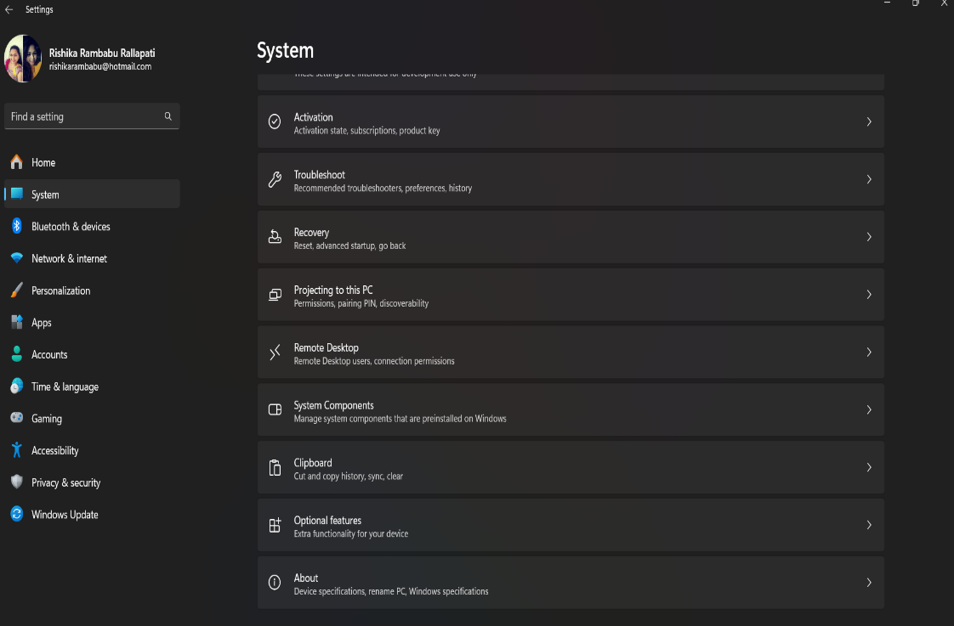

Unable to Enable the Remote Desktop in Windows 11 as it isn’t available for this edition
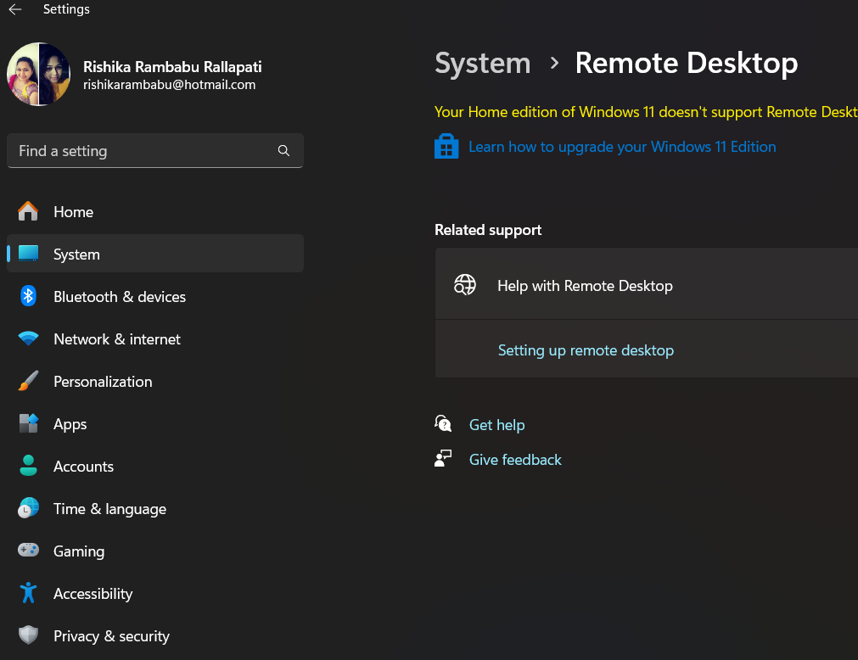
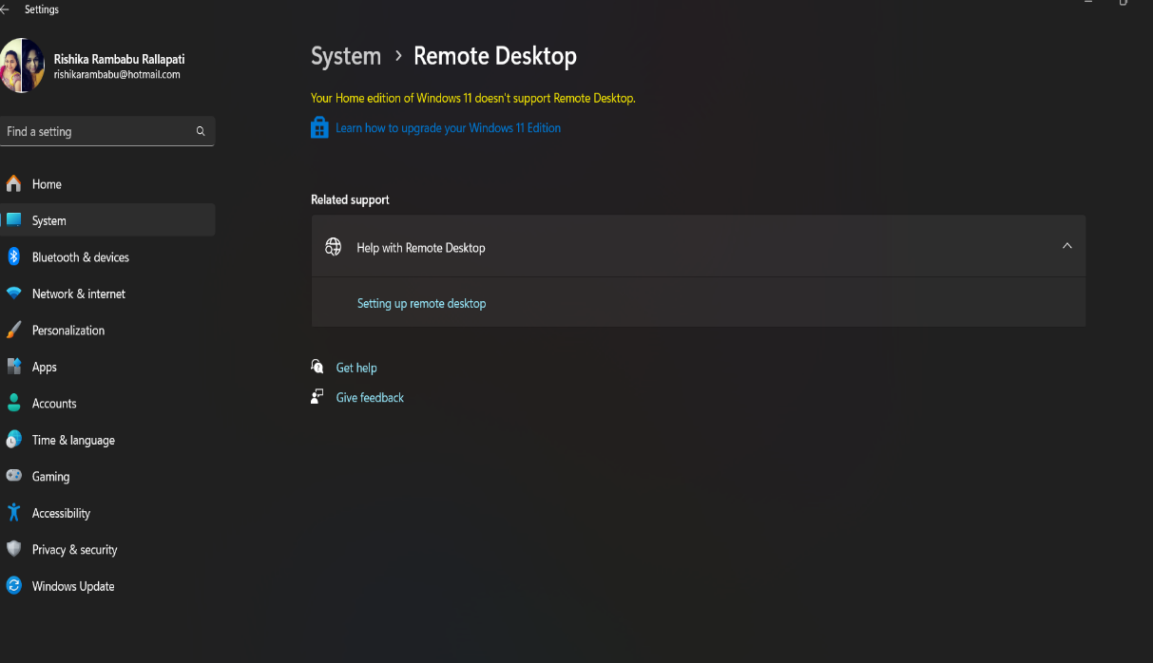
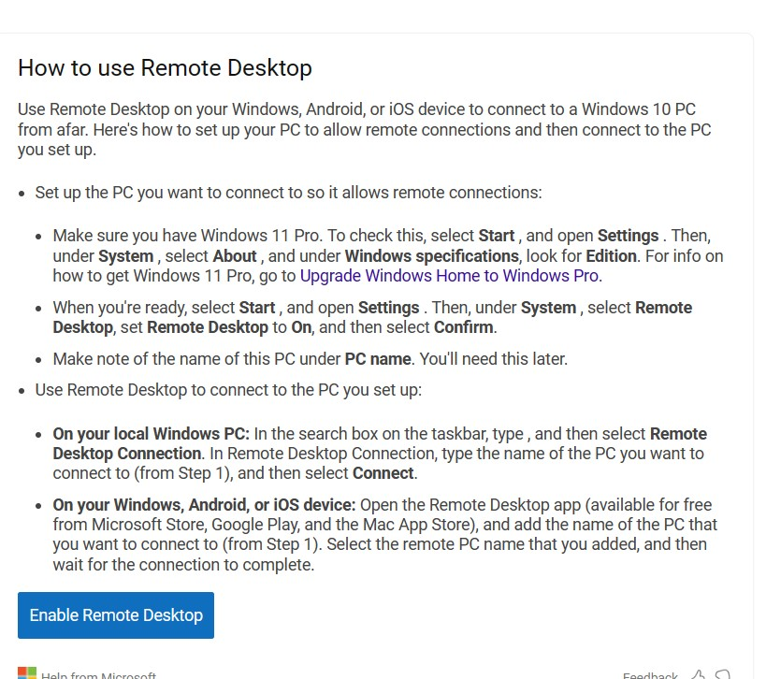
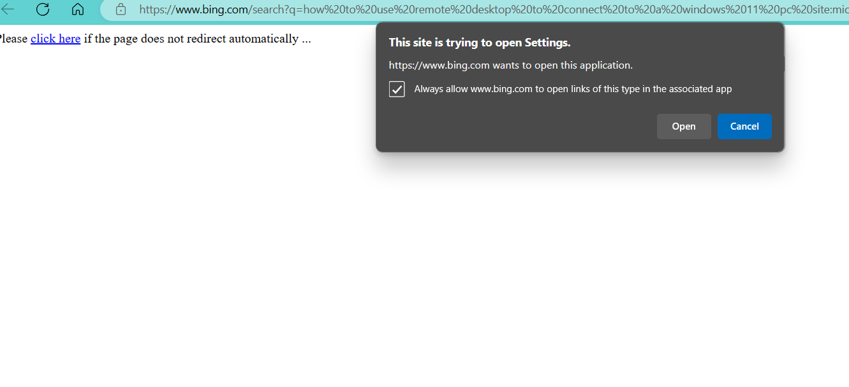
As Remote Desktop is not available in the host machine proceeding with virtual machine.
Find for Remote Desktop Connection on Start Menu
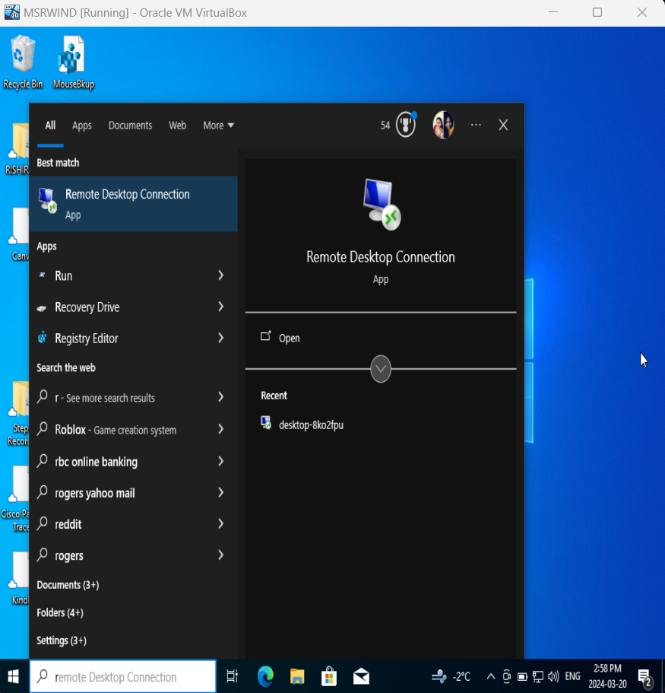

Enter the ip address of the device we need to remotely access
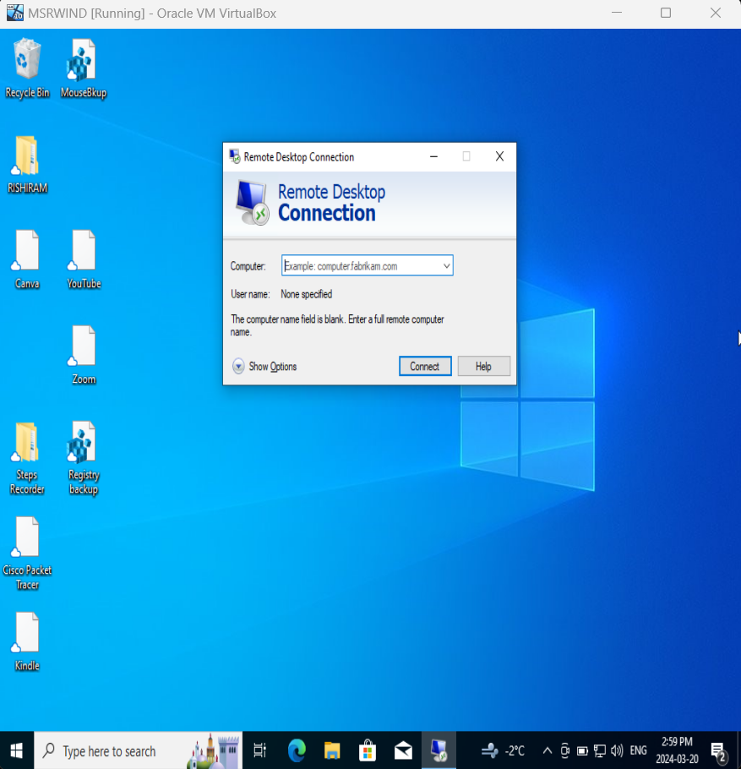
Give the Device name of the device we need to remotely access and click on connect
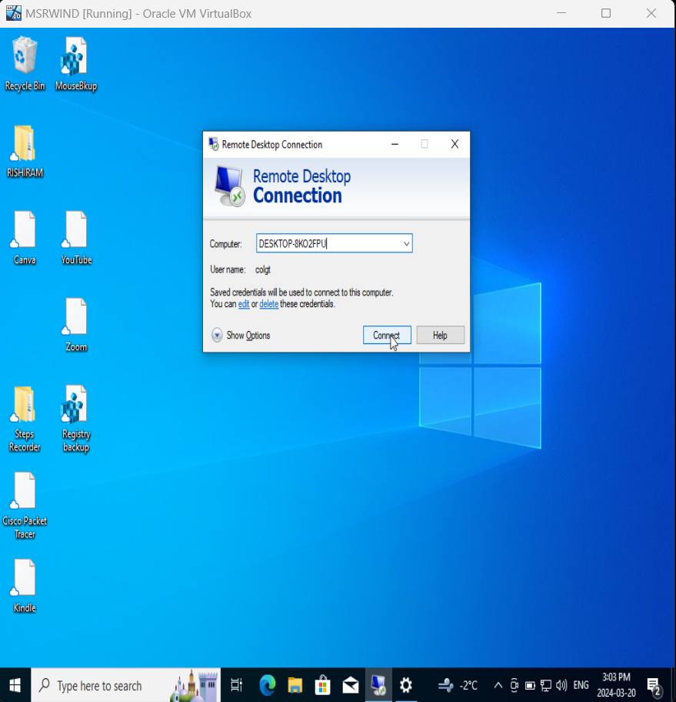
Error message is popped as remote desktop is not enabled in the VB1
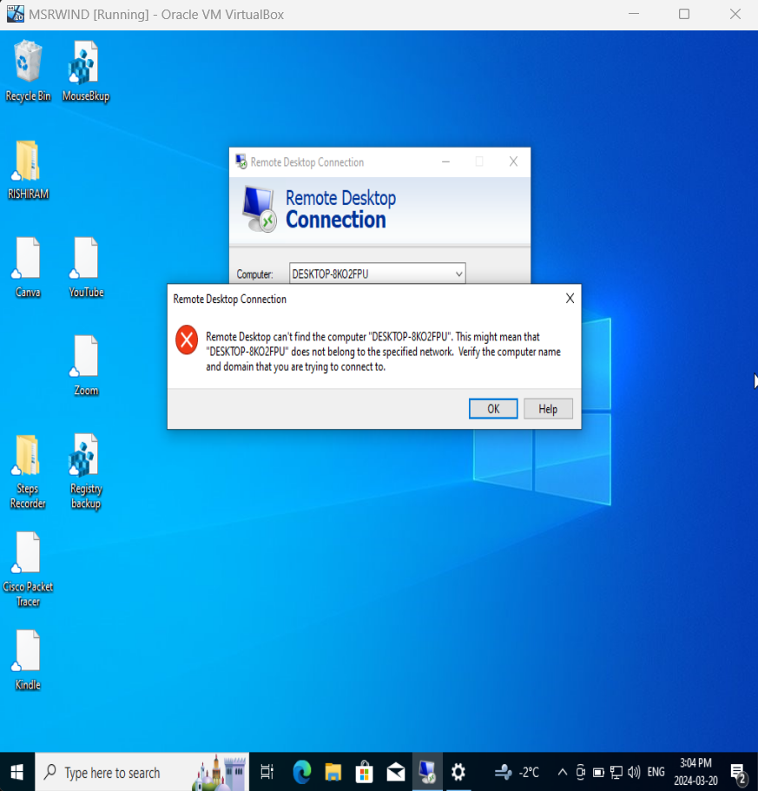
Click on settings Click on System
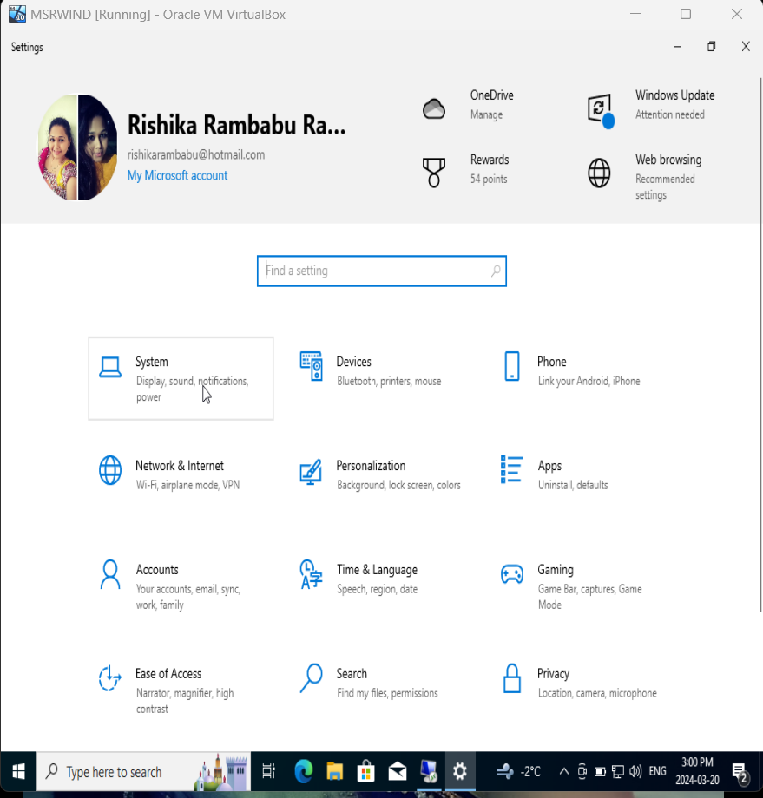

Find the Remote Desktop in the Systems folder
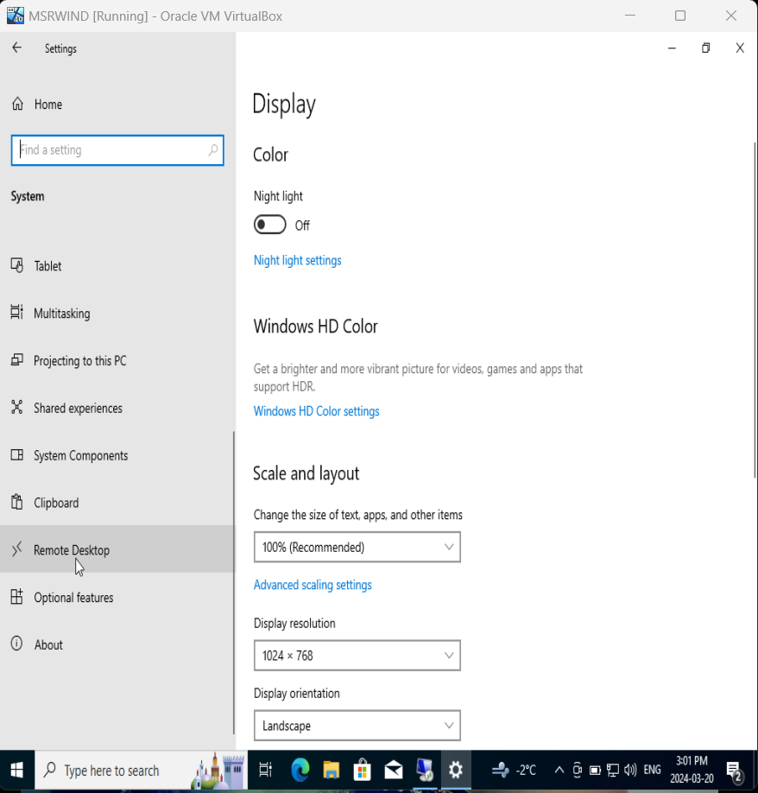
Toggle to the “Enable Remote Desktop” bar
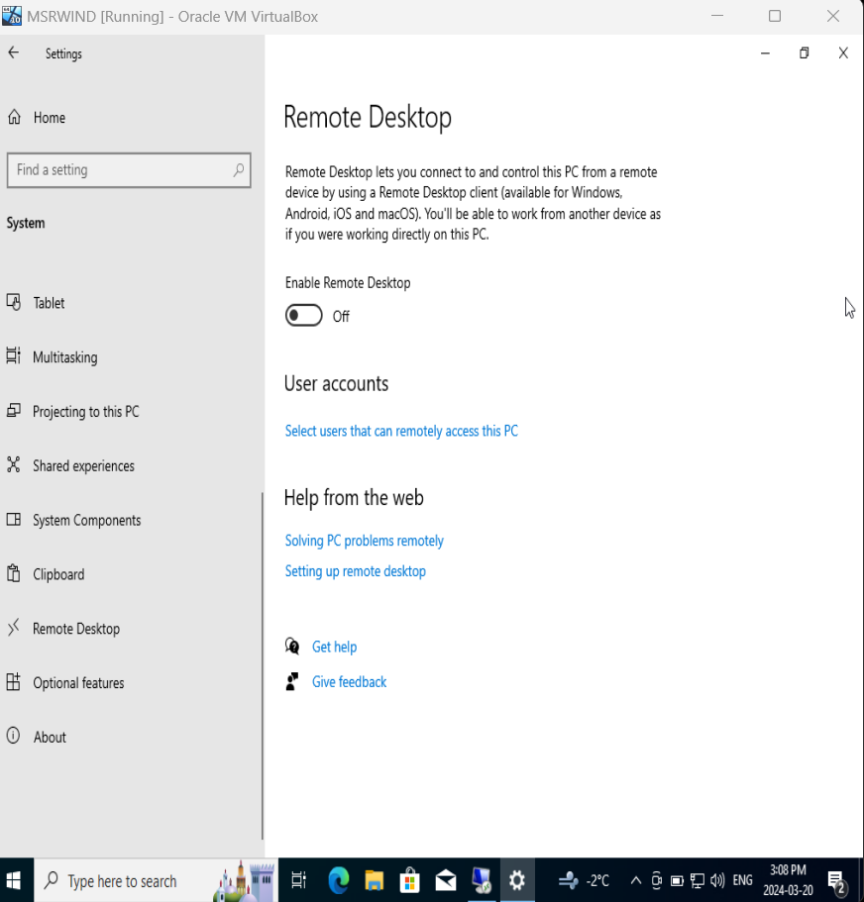

Click on Confirm to Enable the Remote Desktop Connection
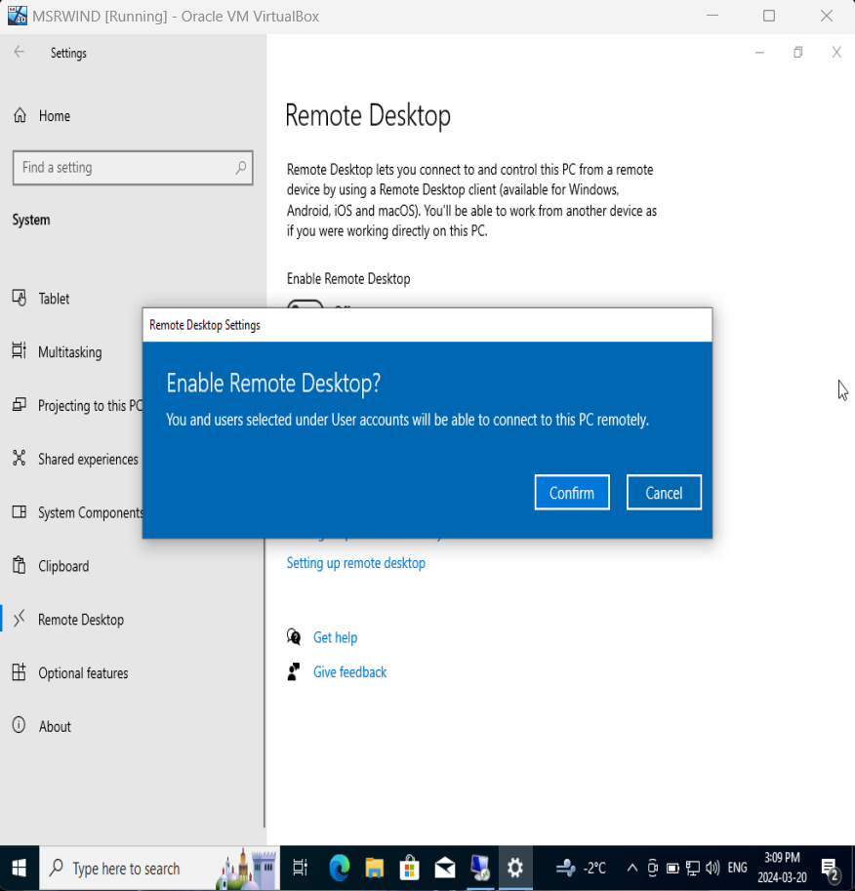
Remote Desktop connection is now enabled now go back to the start menu and find remote desktop connection
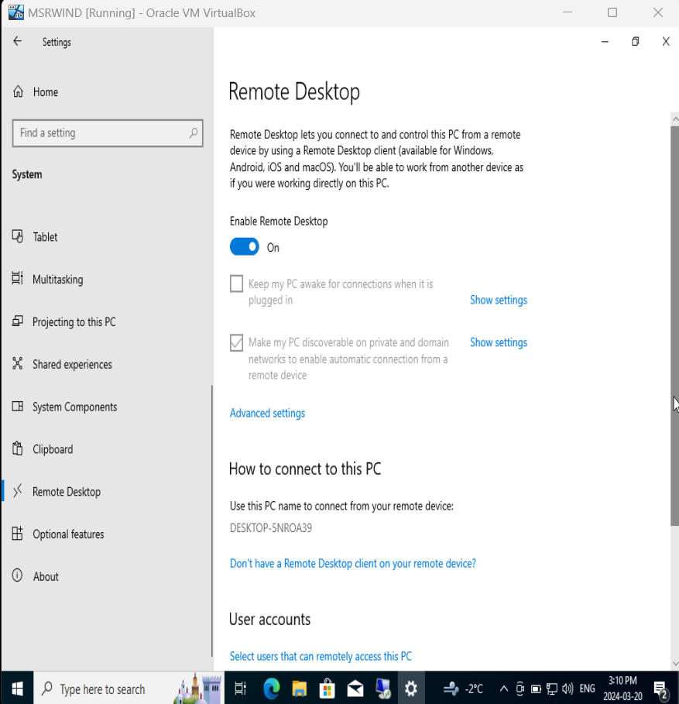

Give the device name of the VB2 in VB1
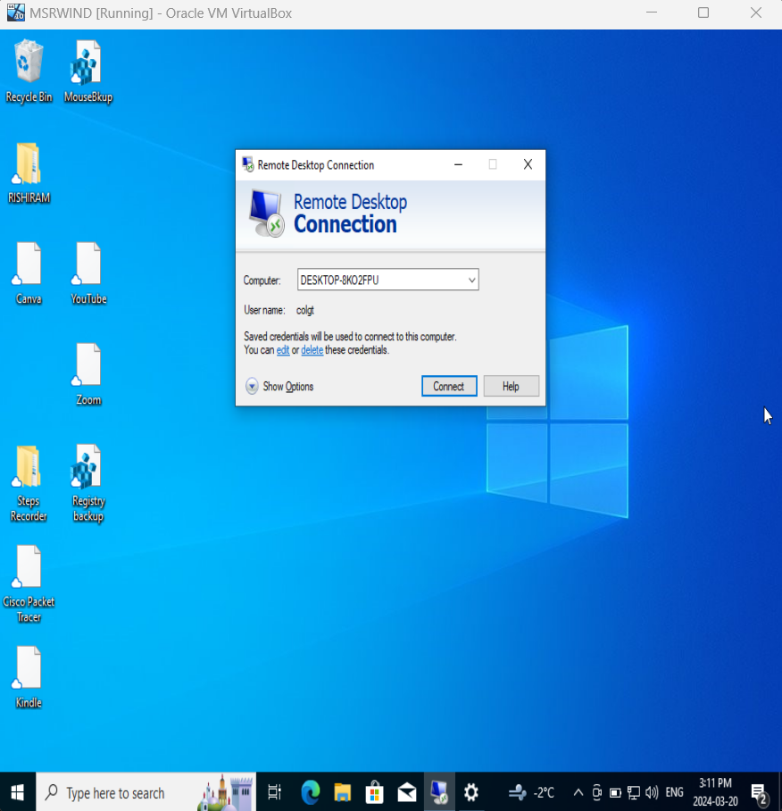
In command prompt enter “query user” to find the device name of VB2
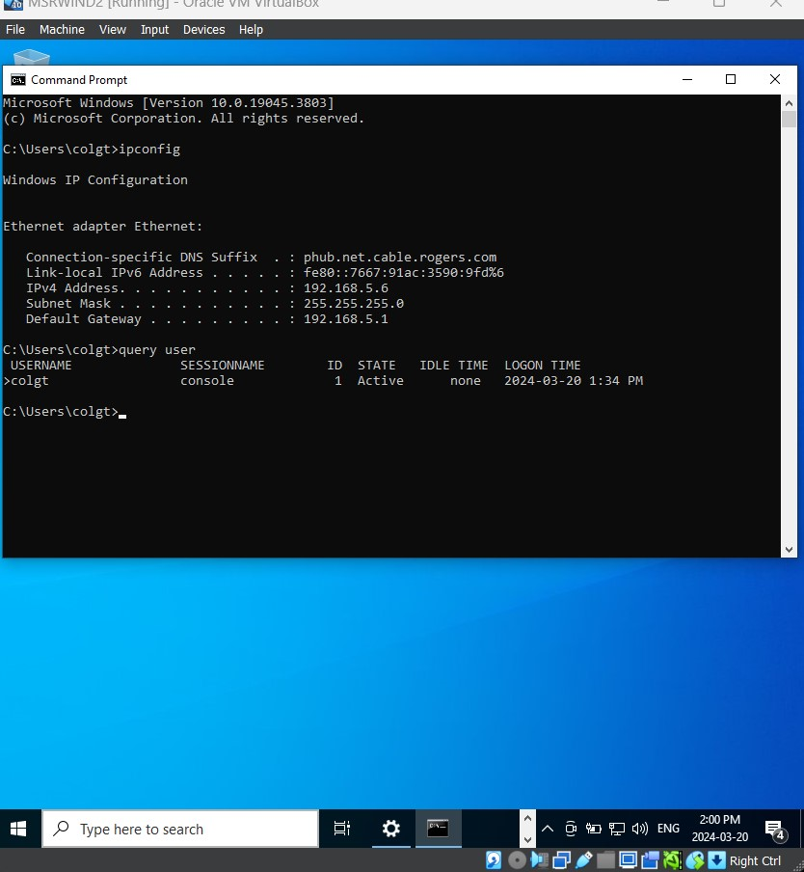
Enable the remote desktop in settings of VB2
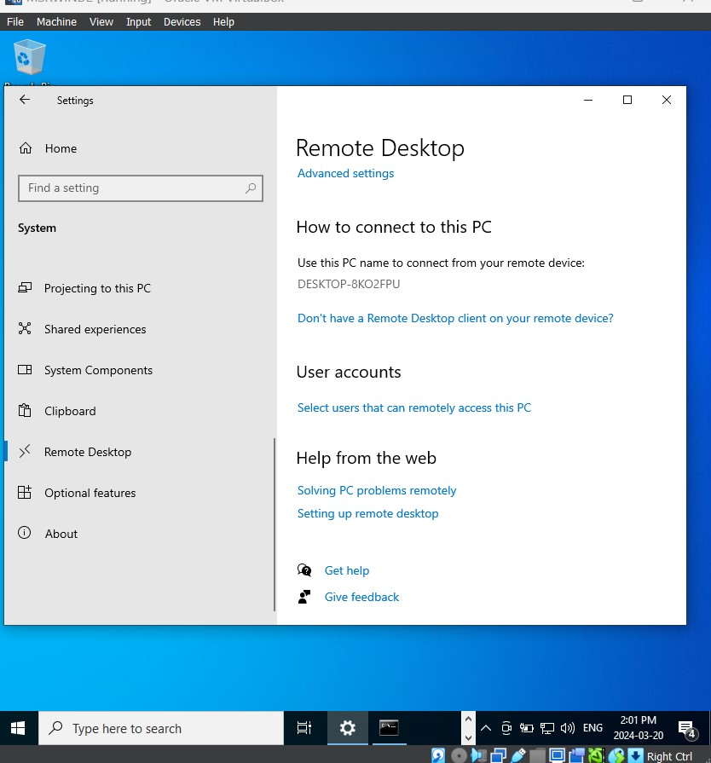
In VB1 enter the VB2 username found in VB2’s command prompt
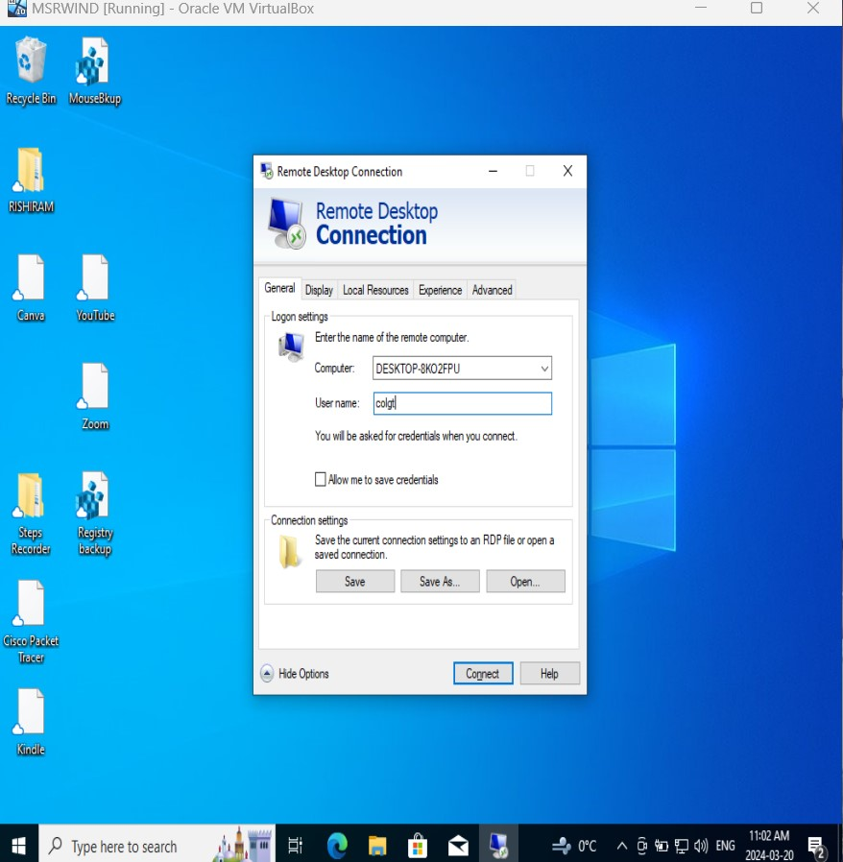

Enter the password of VB2 in Remote Desktop Connection
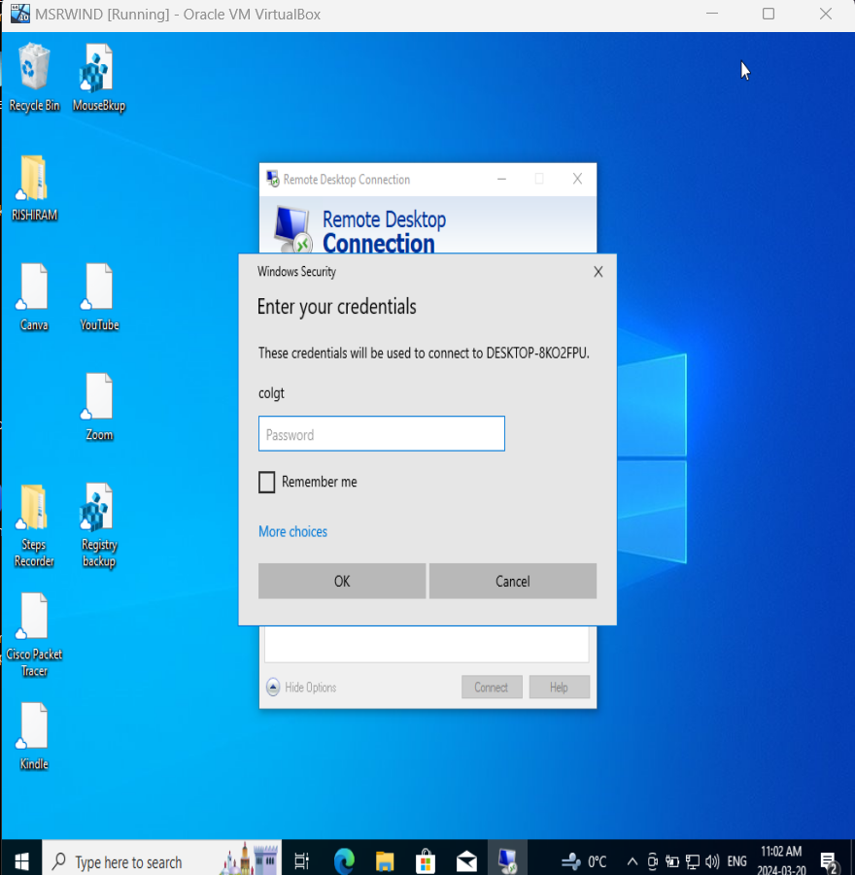
Click on Yes to confirm
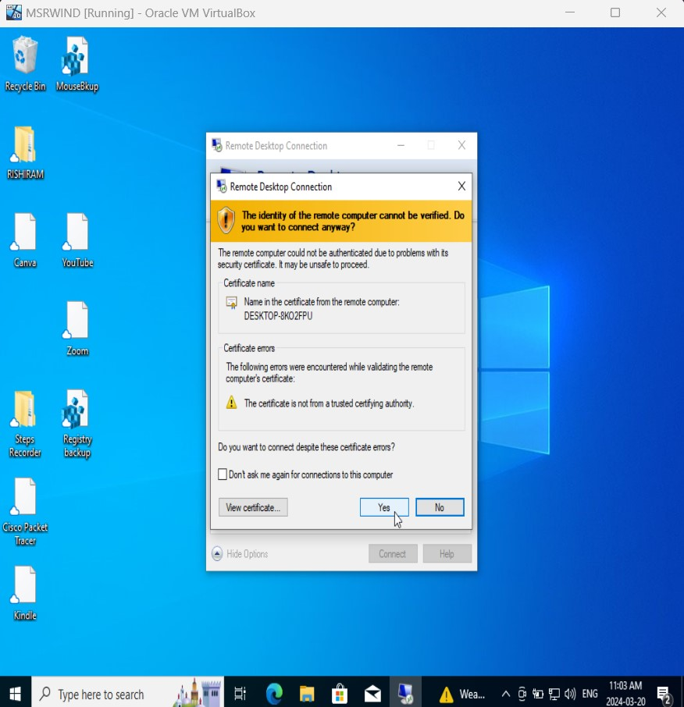

Now we are able to view the VB2 screen in VB1 as the remote desktop connection is established
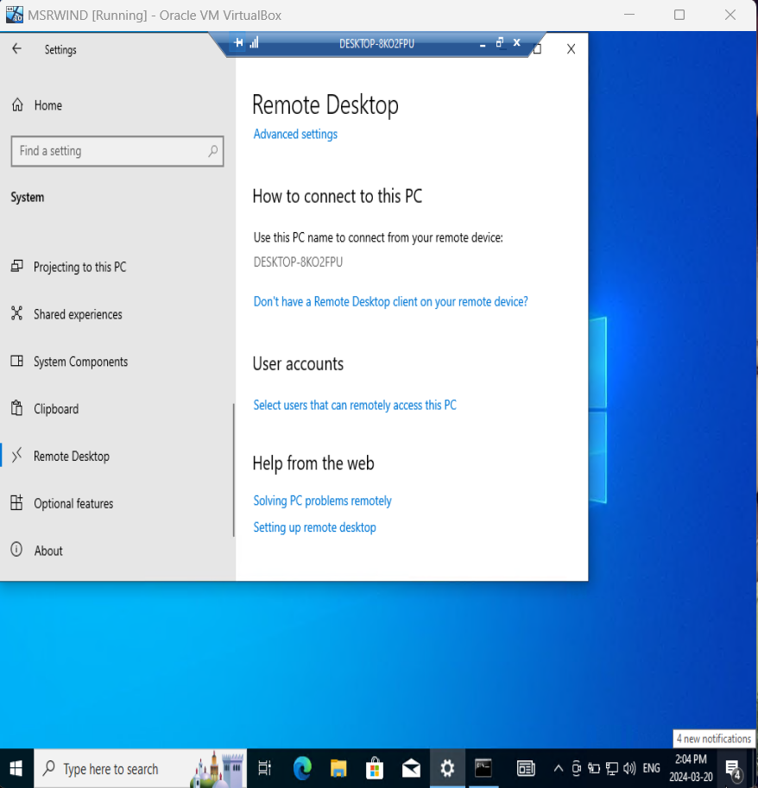
We can verify the command prompt of VB2 in VB1 screen
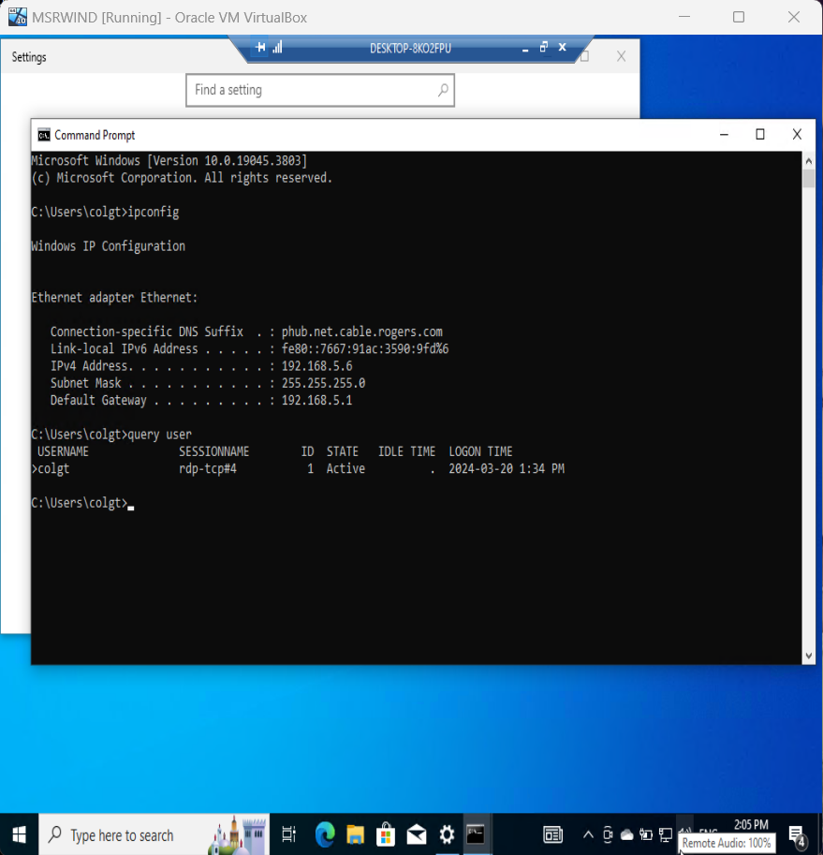
By clicking OK remote session can be disconnected.
